Ascension Day Service

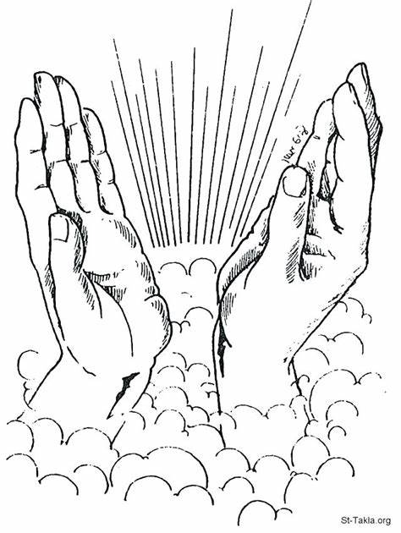
21st May 2020, Ascension Day, marks the first day of Thy Kingdom Come - an annual invitation to prayer called by the Archbishops of Canterbury and York. Over eleven days, the focus is specific prayer in churches, households and as individuals for friends, families, communities and countries to come to know the saving love of God in Jesus Christ, and for ourselves that empowered by God’s Spirit we would grow in confidence to show and tell of God’s love.

So let us gather as the church from Facebook and beyond, to join in this global prayer movement, in praying together with Christians from 172 countries and 65 denominations
Opening Prayer
Almighty God, your ascended Son has sent us into the world to preach the good news of your kingdom: inspire us with your Spirit and fill our hearts with the fire of your love, that all who hear your Word may be drawn to you, through Jesus Christ our Lord.

Sisters and brothers in Christ, for forty days we have been celebrating with joyful hearts the resurrection of our Lord Jesus Christ, his bursting from the tomb and his defeat of the power of sin and death. He appeared to his disciples many times and told them about the kingdom of God.

Today we recall how he left this earth and returned to his Father, ascending into heaven to take his throne over all dominions and powers. Trusting in his reign over all creation, and submitting to his kingly yet loving rule, let us hear once again the story of his parting.

Bible Reading: Luke 24:44-53 (NRSV):
Then he [Jesus] said to them, “These are my words that I spoke to you while I was still with you—that everything written about me in the law of Moses, the prophets, and the psalms must be fulfilled.” Then he opened their minds to understand the scriptures, and he said to them, “Thus it is written, that the Messiah is to suffer and to rise from the dead on the third day, and that repentance and forgiveness of sins is to be proclaimed in his name to all nations, beginning from Jerusalem. You are witnesses of these things. And see, I am sending upon you what my Father promised; so stay here in the city until you have been clothed with power from on high.”
Then he led them out as far as Bethany, and, lifting up his hands, he blessed them. While he was blessing them, he withdrew from them and was carried up into heaven. And they worshiped him, and returned to Jerusalem with great joy; and they were continually in the temple blessing God.

Prayer for today
O God of glory, sovereign of all nations the risen and ascended Christ calls us to carry your message of life to all people. Led by the power of your Holy Spirit, may we witness always to the hope to which we are called as we share Christ’s love to the ends of the earth. Amen

A Hymn for Thy Kingdom Come
(Tune: Woodlands ~ Tell Out My Soul)
Thy Kingdom Come – Lord teach us how to pray
For all to know your joy, your peace and love
And know your friendship each and every day
The breath of Christ, the Father’s gentle dove

Thy Kingdom Come – Christ’s prayer to make us one
That all may know the Father sent the Son
To celebrate the victory He has won
In love and grace we pray: ‘thy will be done’

Thy Kingdom Come – we pray for those we know
To turn and follow you for all their days
and in your love find peace and service grow
Our one desire and hope your highest praise

Thy Kingdom Come – transform our human ways
Our lives laid down in mercy, truth and care
Nations renewed, in giving thanks and praise
To see God’s Kingdom come: this is our prayer

Thy Kingdom Come – we praise your Holy name
Your sacrifice and rising sets us free
That by our words and lives we may proclaim
By Jesus’ risen life, God’s victory!
Words: Neil Hamilton Thompson, Chris Russell, Emma Buchan, Harvey Jessop ©2020 Neil Hamilton Thompson, Chris Russell, Emma Buchan, Harvey Jessop

Thy Kingdom Come is a call to prayer, during this time may we:

• Remember Our Calling as God’s people – to worship, to learning and caring, to service, and to sharing the love of God to others?

• Reflect on the disciples – who waited in faithful expectation between Ascension and Pentecost for the outpouring of God’s Spirit.

• Respond in word and deed – a key feature of Thy Kingdom Come is the commitment to pray for five people to come to know Jesus.

You are therefore invited to use the colouring image on the front page to pray silently for the five people who you would like to come to know the love of Jesus Christ. (it can be more or less if you wish!)

Closing prayer and the Grace
Together we are sharers in God’s kingdom,
Together we are builders of God’s kingdom.
May all that we say, and do, and are, be grounded in God’s love.
So that the grace of our Lord Jesus Christ,
the love of God and the fellowship of the Holy Spirit
will be with us all this day and always. Amen.

Service compiled by Rev’d Kim Shorely

Please be assured that we are still here if you need anything at all during this time. Contact Vanda via private message on Facebook or email canonvanda@gmail.com

