13th December Wreath Prayers, Reading, Reflection and Intercessions
THE THIRD SUNDAY OF ADVENT: JOY
The third candle of Advent is the Candle of Joy. It reminds us of the joy that Mary felt when the angel Gabriel told her that a special child would be born to her - a child who would save and deliver his people.
God wants us all to have joy. The angel who announced to the shepherds that Jesus had been born told them: "Do not be afraid. I am bringing you good news of great joy for all people - for to you is born this day, in the City of David, a Saviour, who is the Messiah, the Lord." We light this candle to remember that He is the bringer of true and everlasting joy. (Light Advent Candle Three - Pink)
Let us pray - Loving God, we thank you for the joy you bring us. Help us prepare our hearts for this gift. Bless our worship. Help us to hear and to do your word. We ask it in the name of the one born in Bethlehem, Jesus our Lord. Amen.
The Collect
God for whom we watch and wait, you sent John the Baptist to prepare the way of your Son: give us courage to speak the truth,
to hunger for justice, and to suffer for the cause of right, with Jesus Christ our Lord. Amen.

Reading Isaiah 61.1-3
The servant of the Lord said:
¹ The spirit of the Lord GOD is upon me,
because the LORD has anointed me;
he has sent me to bring good news to the oppressed,
to bind up the broken-hearted,
to proclaim liberty to the captives,
and release to the prisoners;
² to proclaim the year of the LORD’s favour,
and the day of vengeance of our God;
to comfort all who mourn;
³ to provide for those who mourn in Zion –
to give them a garland instead of ashes,
the oil of gladness instead of mourning,
the mantle of praise instead of a faint spirit.
This is the word of the Lord Thanks be to God.

Gospel Reading
Hear the Gospel of our Lord Jesus Christ according to John 1: 1-5
Glory to you, O Lord.

In the beginning was the Word. The Word was close beside God, and the Word was God. In the beginning, he was close beside God. All things came into existence through him; not one thing that exists came into existence without him. Life was in him and this life was the light of the human race. The light shines in the darkness, and the darkness did not overcome it.
This is the Gospel of the Lord. Praise to you, O Christ.

Reflection
This year has been unlike any other. Lots of challenges and lots of learning about how to do things differently. But there is also much that is the same.
Some of us are reaching Christmas without someone we love next to us, the depth of pain and sorry this brings does not enable us face Christmas with joy. Some of us are spending our Christmas alone without our family or friends to visit. Some are facing a bleak financial future and are worried about jobs, mortgages, rent and affording the next bills. Others are struggling with depression and despair.
In spite, or despite of this, the relentless march of time brings Christmas close whether we want to celebrate or not. This Sunday is a chance for each one of us to pause and remember those who are not at our celebrations this year. To acknowledge that it is a difficult year for many. Ourselves included. To allow ourselves to grieve for those who have died, for those relationships that are fractured beyond healing, and for the Christmas you had hoped to celebrate this year.

The first Christmas was hard. Travelling while close to birth, and nowhere to stop – the strange circumstances of the visitors, the threat of Herod. The first Christmas was one of pain and fear, uncertainty and worry.

But that was not the whole story. For the first Christmas also has the wonder of the new born son, safely delivered despite the circumstances. The joy of God’s Messengers, the angels, the Good News they shared. The awesome response of the shepherds, the wisdom of the Magi in helping the Holy Family flee to safety.

We can see clearly that amidst the horrors and fears, the bereavement of being in an alien place without the care of her family while Mary brings to birth God Made Man, here is also found grace, hope, love and joy.
No matter how different this Christmas is for you, even when it is painful and difficult for you, my prayer is that you know the love of God to surround you, the peace of God to fill you, the hope of God to inspire you and the grace of God to give you strength to meet the coming days. The Light shines in the darkness, and the darkness did not overcome it. Not then, not now. Not ever. Amen.

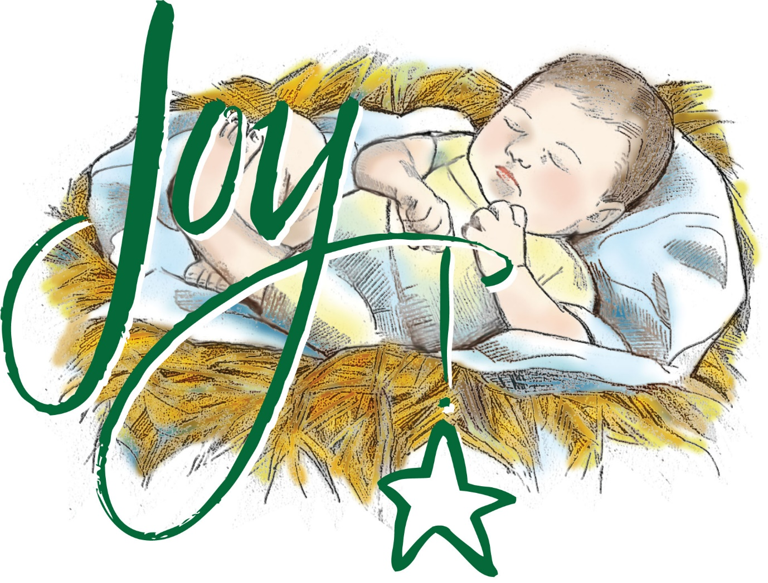

Intercessions by Helen Briggs Blue Christmas, 3rd Advent

As we approach a Christmas period that will be very different from usual for so many people this year, we pray especially for all those who have suffered bereavement over the past year, whether from Covid 19 or for any other reason.

We pray for those in the health service, who have given their lives caring for the sick and endangering their own health as a result. Be with the bereaved Lord and help them to feel your love and care as they try to come to terms with their loss.
Lord in your mercy, hear our prayer

We ask your blessing on all those who are ill, mentally or physically whether at home, in care homes or in hospital and for all those who care for them. This festive season will be anything but festive for so many and for some, understanding the reason why their lives have changed so dramatically, is very hard. We pray for all those who are hungry, for those relying on foodbanks, for the homeless, for those without work.

And we pray for all those agencies who are striving to help them. Help them to feel the strength of your presence O Lord, to see them through the weeks and months ahead and let the healing grace of your love, so transform us all in such a way that we may play our part in the transfiguration of the world from a place of suffering, death and sorrow to a realm of infinite light, joy and love.
Lord in your mercy hear our prayer

Thank you, Lord, for the gift of our senses which enable us to enjoy the beauty of the world in which we live and for all the gifts that nature bestows on us. We thank you for the amazing wildlife we can enjoy both on land and in the sea. Help us to draw strength from the landscapes, seascapes and the beauty of the stars as we wait for the first snowdrop and the return of the warming rays of the sun.

And we thank you for the gift of hope, for the promise of new life that the coming spring affords us, an ever present help in this time of trouble. We give you thanks for all those who have worked so hard and have succeeded in finding a vaccine for the coronavirus, both scientists and volunteers, thus giving us hope that our lives may once more be enriched by the company of others, and with our friends and family. Enrich us all by hope and thereby enable us to enrich life for others
Lord in your mercy hear our prayer

The words of the book of Joshua help us all when they say ‘Be strong and of a good courage, be not afraid neither be thou dismayed for thy Lord thy God is with thee whithersoever thou goest’
Merciful Father accept these prayers for the sake of your son, our Saviour Jesus Christ, Amen.

